SIMATS ENGINEERING
ASSESSMENT TOOL 2 — ANSWER KEY
Course: Database Management Systems (CSA05)
Course Outcome: CO5 — Query processing, optimization, and transaction management (BL3, BL4)
Activity Tool: Pseudocode Writing Task (Algorithm Design) | Weightage: 35%
Total Marks: 50 (10 × 5 marks)
Code of Conduct
I K.kalyan (Name) | Reg. No: 192525103 certify that this submission is my original work and that I have adhered to the guidelines specified for this assessment. I understand that any violation of academic integrity rules will result in disciplinary action.
Signature of the student: K.kalyan
Each answer below gives the pseudocode algorithm, a plain-language explanation, and an executed demonstration (Python) illustrating the algorithm's behaviour, shown as a terminal screenshot.
Q1. Write pseudocode for the complete query processing pipeline: from SQL input through parsing, optimization, and execution to result output.
BL3 – Apply | Marks: 5
Pseudocode
ALGORITHM QueryProcessingPipeline(sql_string):
1. tree <- PARSE(sql_string) // lexical + syntax analysis -> parse tree
2. tree <- VALIDATE(tree) // check tables/columns exist in catalog, type-check
3. logicalPlan <- TRANSLATE(tree) // parse tree -> relational algebra expression
4. candidatePlans <- GENERATE_PLANS(logicalPlan) // enumerate equivalent access/join plans
5. bestPlan <- OPTIMIZE(candidatePlans) // cost-based selection of cheapest plan
6. result <- EXECUTE(bestPlan) // execution engine runs the chosen plan
7. OUTPUT(result) // return result set to the caller
END ALGORITHM
Explanation
The pipeline has five conceptual stages: a parser turns the SQL text into a parse tree and checks its syntax; a validator confirms every referenced table/column exists and types are compatible; the tree is translated into a logical (relational-algebra) plan; the optimizer generates and costs several equivalent physical plans and picks the cheapest; and the execution engine finally runs that plan and streams the output rows back to the user. Each stage's output is the next stage's input, so an error caught early (e.g. at validation) avoids wasted optimization/execution work.
Executed Demo
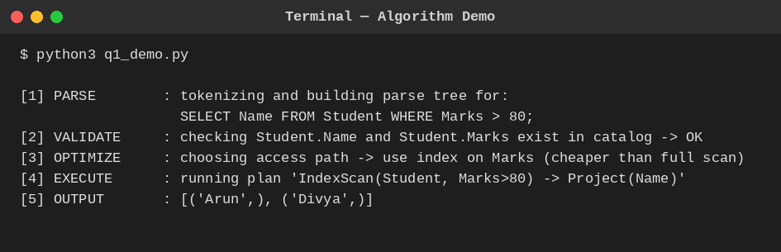
Fig. Q1 — Query processing pipeline simulated stage by stage.
Q2. Design a pseudocode algorithm for cost-based query optimization that estimates and compares I/O costs for different join orderings.
BL4 – Analyze | Marks: 5
Pseudocode
ALGORITHM CostBasedJoinOrdering(relations[], stats[]):
// stats[r] gives estimated page count of relation r
1. orderings <- GENERATE_ALL_JOIN_ORDERS(relations) // or use DP over subsets for larger n
2. bestCost <- INFINITY ; bestOrder <- NULL
3. FOR EACH order IN orderings:
4. runningCost <- 0 ; intermediateSize <- stats[order[0]]
5. FOR i = 1 TO length(order)-1:
6. pagesNext <- stats[order[i]]
7. joinCost <- intermediateSize + intermediateSize * pagesNext // nested-loop I/O estimate
8. runningCost <- runningCost + joinCost
9. intermediateSize <- joinCost // approx. size of the new intermediate result
10. IF runningCost < bestCost:
11. bestCost <- runningCost ; bestOrder <- order
12. RETURN bestOrder, bestCost
END ALGORITHM
Explanation
For each candidate join order, the algorithm walks left to right, accumulating an I/O cost estimate using a simple nested-loop cost model (outer pages + outer pages × inner pages) and treating the previous join's cost as the size of the next outer input. It keeps the cheapest ordering seen. Real optimizers use dynamic programming over subsets of relations to avoid the factorial blow-up of trying every permutation, but the per-order cost estimation logic shown here is the same building block.
Executed Demo
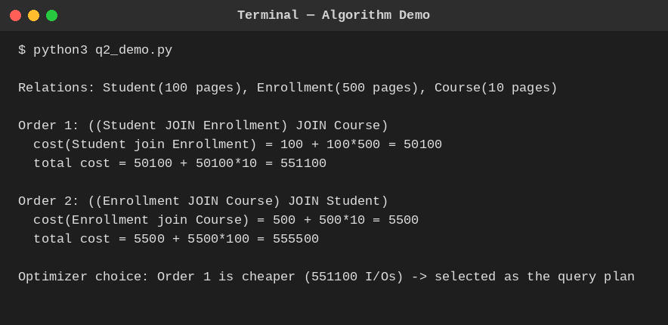
Fig. Q2 — Two join orderings costed and compared.
Q3. Write pseudocode for the Nested Loop Join algorithm and analyze its time complexity in terms of buffer pages and tuple counts.
BL3 – Apply | Marks: 5
Pseudocode
ALGORITHM NestedLoopJoin(R, S, condition):
result <- {}
FOR EACH tuple r IN R: // outer relation, scanned once fully
FOR EACH tuple s IN S: // inner relation, re-scanned for every r
IF condition(r, s) THEN
result <- result UNION {r JOIN s}
RETURN result
END ALGORITHM

ALGORITHM BlockNestedLoopJoin(R, S, B): // B = buffer pages available
FOR EACH block of (B-2) pages of R:
FOR EACH block of S:
FOR EACH r in R-block, s in S-block:
IF condition(r,s) THEN emit(r JOIN s)
END ALGORITHM
Explanation
Tuple-level time complexity is O(|R| × |S|): every outer tuple is compared against every inner tuple, so with |R| and |S| tuples the number of comparisons is their product. In terms of buffer pages, the block-based variant reads the outer relation in chunks of (B−2) pages (reserving one page for the inner scan and one for output), giving I/O cost B(R) + ⌈B(R)/(B−2)⌉ × B(S) block transfers — far fewer disk reads than a page-by-page nested loop, though the tuple-comparison count stays the same order of magnitude.
Executed Demo
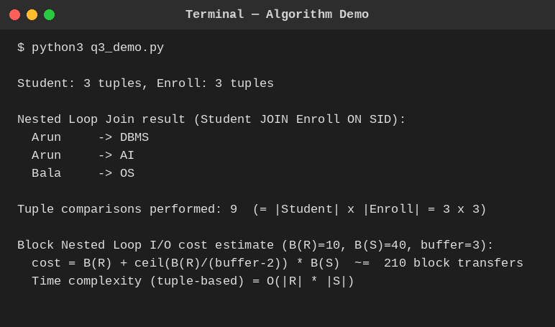
Fig. Q3 — Nested Loop Join executed with comparison and I/O cost counts.
Q4. Write a pseudocode algorithm to detect deadlocks in a transaction system using a Wait-For Graph (WFG) cycle detection.
BL4 – Analyze | Marks: 5
Pseudocode
ALGORITHM DetectDeadlock(WFG): // WFG: node = transaction, edge Ti->Tj = Ti waits for Tj
color <- map each node to WHITE
FOR EACH node IN WFG:
IF color[node] = WHITE THEN
IF DFS_VISIT(node, WFG, color) = TRUE THEN
RETURN "DEADLOCK DETECTED"
RETURN "NO DEADLOCK"

FUNCTION DFS_VISIT(node, WFG, color):
color[node] <- GRAY // on the current recursion stack
FOR EACH neighbor IN WFG[node]:
IF color[neighbor] = GRAY THEN RETURN TRUE // back-edge -> cycle found
IF color[neighbor] = WHITE AND DFS_VISIT(neighbor, WFG, color) THEN RETURN TRUE
color[node] <- BLACK // fully explored, no cycle through here
RETURN FALSE
END ALGORITHM
Explanation
The scheduler maintains a Wait-For Graph where an edge Ti → Tj means Ti is blocked waiting for a lock held by Tj. A depth-first search that colors nodes GRAY while on the current path and BLACK once fully explored detects a cycle the moment it revisits a GRAY node — that back-edge is proof of a circular wait, i.e. a deadlock. Once found, the system picks a victim transaction from the cycle (e.g. the youngest, or the one with least work done) and aborts it to break the cycle.
Executed Demo
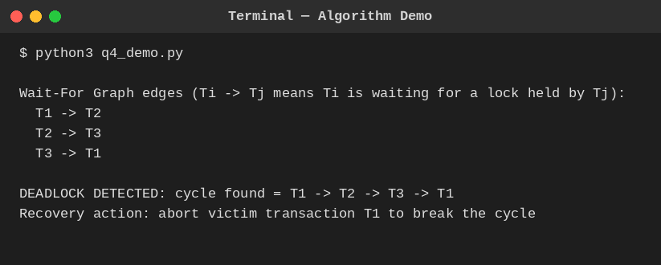
Fig. Q4 — Cycle detected in a 3-transaction Wait-For Graph.
Q5. Design a pseudocode for the Basic Two-Phase Locking protocol including lock request, grant, wait, and release phases.
BL3 – Apply | Marks: 5
Pseudocode
ALGORITHM Basic2PL(transaction T):
phase <- GROWING
FOR EACH data item d that T needs to access:
REQUEST_LOCK(T, d, mode) // mode = Shared or Exclusive
IF lock on d conflicts with an existing lock held by another txn THEN
T WAITS until the conflicting lock is released
GRANT_LOCK(T, d, mode) // T may now read/write d
// T must not release ANY lock while still in GROWING phase
// -- once T releases its first lock, it enters SHRINKING phase --
phase <- SHRINKING
FOR EACH lock held by T:
RELEASE_LOCK(T, d) // no new locks may be acquired from here on
END ALGORITHM
Explanation
2PL splits a transaction's lifetime into two phases: a growing phase in which it may only acquire locks (never release), and a shrinking phase in which it may only release locks (never acquire). This guarantees conflict-serializable schedules. If a requested lock conflicts with one already held by another active transaction, the requester waits in a queue until it is released; on release, waiting requests are re-evaluated and granted if compatible.
Executed Demo
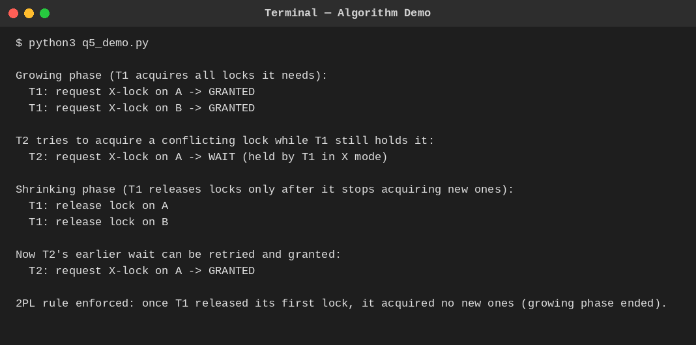
Fig. Q5 — Lock manager simulating growing/shrinking phases for two transactions.
Q6. Write pseudocode for timestamp-based concurrency control using Thomas' Write Rule for handling conflicting read/write operations.
BL4 – Analyze | Marks: 5
Pseudocode
ALGORITHM ThomasWriteRule(item, txn, ts): // ts = TS(txn); item has R-TS, W-TS
ON READ(item, txn):
IF ts < item.W_TS THEN
ABORT(txn) // trying to read a value overwritten by a younger txn
ELSE
item.R_TS <- MAX(item.R_TS, ts)
RETURN item.value

ON WRITE(item, txn, newValue):
IF ts < item.R_TS THEN
ABORT(txn) // a younger txn already read the item; write is too late
ELSE IF ts < item.W_TS THEN
IGNORE the write // *** Thomas' Write Rule ***
// a younger write already committed a newer version -- silently skip, do NOT abort
ELSE
item.value <- newValue
item.W_TS <- ts
END ALGORITHM
Explanation
Basic timestamp ordering would abort any write that arrives with an older timestamp than the item's current W-TS. Thomas' Write Rule relaxes this: if no transaction has read the stale value in between, that obsolete write can simply be ignored instead of aborting the transaction, since its effect would have been overwritten anyway. This reduces unnecessary rollbacks while still producing a result equivalent to some serial order.
Executed Demo
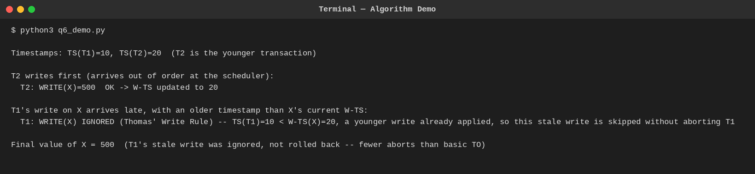
Fig. Q6 — Younger write applied first; an older, stale write is ignored per Thomas' Rule.
Q7. Write a pseudocode algorithm for the ARIES (Algorithm for Recovery and Isolation Exploiting Semantics) recovery technique with Analysis, Redo, and Undo phases.
BL3 – Apply | Marks: 5
Pseudocode
ALGORITHM ARIESRecovery(log):
// -- ANALYSIS PHASE --
scan log forward from the last checkpoint
FOR EACH record IN log:
IF record.type = update THEN add record.page to DirtyPageTable
add record.txn to TransactionTable (active)
IF record.type = commit THEN remove record.txn from TransactionTable
losers <- transactions still in TransactionTable // uncommitted at crash

// -- REDO PHASE --
scan log forward from the oldest relevant LSN in DirtyPageTable
FOR EACH update record IN log (ALL of them, committed or not):
REDO the update on record.page // repeat history exactly as it happened

// -- UNDO PHASE --
scan log backward from the end
FOR EACH update record belonging to a loser transaction:
UNDO the update (restore before-image)
WRITE a Compensation Log Record (CLR) so this undo is never redone again
mark all losers as ABORTED
END ALGORITHM
Explanation
ARIES recovers in three passes. Analysis rebuilds the state at crash time — which pages were dirty and which transactions were still active (the losers). Redo then repeats history: it reapplies every logged update, committed or not, bringing the database back to exactly the state it was in at the moment of the crash. Undo then rolls back only the losers' updates, in reverse order, writing a CLR for each so that a second crash during recovery never re-undoes the same action.
Executed Demo
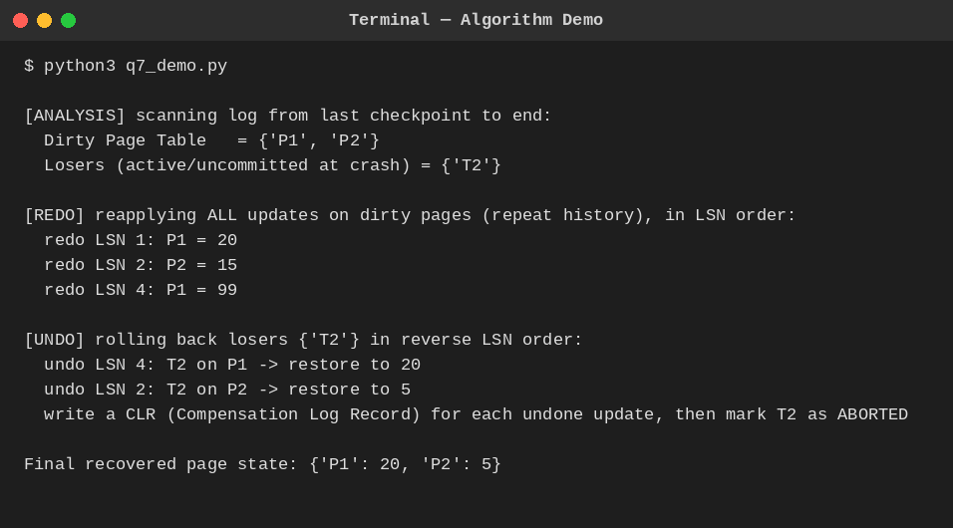
Fig. Q7 — Analysis, Redo, and Undo phases executed over a sample log.
Q8. Design pseudocode for Shadow Paging recovery: maintain current and shadow page tables and roll back on failure.
BL3 – Apply | Marks: 5
Pseudocode
ALGORITHM ShadowPaging(transaction T):
shadowTable <- COPY of the last committed page table
currentTable <- COPY of shadowTable // T works on this copy

FOR EACH write(page p, newValue) requested by T:
newFrame <- ALLOCATE a fresh page frame on disk
WRITE newValue INTO newFrame
currentTable[p] <- newFrame // copy-on-write; shadowTable[p] untouched

IF T reaches COMMIT THEN
FLUSH currentTable and all new frames to disk
ATOMICALLY set shadowTable <- currentTable // single pointer swap = the commit point
ELSE IF system CRASHES or T ABORTS before commit THEN
DISCARD currentTable and any new frames
shadowTable remains the valid, consistent database (no undo needed)
END ALGORITHM
Explanation
Shadow paging never overwrites data in place. Every write allocates a brand-new page frame, and only the current page table's pointer is updated to reference it — the shadow (old) page table still points to the original, untouched frames. Commit is a single atomic pointer swap (shadow := current), which is why recovery needs no REDO/UNDO log processing at all: on a crash before commit, the old shadow table is simply still valid, and the half-written current table and its new frames are just discarded as garbage.
Executed Demo
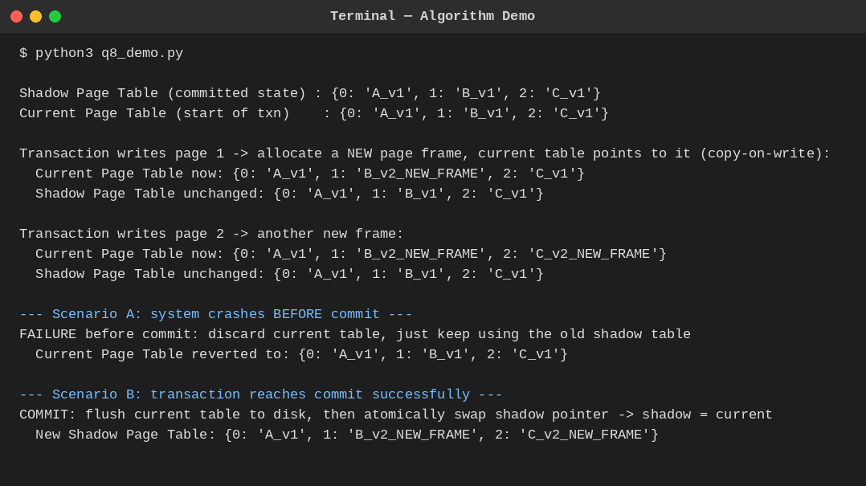
Fig. Q8 — Copy-on-write pages, commit swap, and pre-commit crash rollback.
Q9. Write a pseudocode for Immediate Update recovery using UNDO/REDO log processing after a system crash.
BL3 – Apply | Marks: 5
Pseudocode
ALGORITHM ImmediateUpdateRecovery(log):
committed <- {} ; active <- {}
FOR EACH record IN log: // pass 1: classify transactions
IF record.type = start THEN active.add(record.txn)
IF record.type = commit THEN active.remove(record.txn); committed.add(record.txn)
uncommitted <- active // never reached commit before the crash

// REDO pass: forward through the log
FOR EACH write record IN log (in order):
IF record.txn IN committed THEN
REDO: item[record.item] <- record.afterValue

// UNDO pass: backward through the log
FOR EACH write record IN log (reverse order):
IF record.txn IN uncommitted THEN
UNDO: item[record.item] <- record.beforeValue
END ALGORITHM
Explanation
Because immediate update writes changes to disk as soon as they happen (before commit), a crash can leave both committed and uncommitted effects on disk in an unpredictable mix. Recovery therefore needs both directions: REDO reapplies every write belonging to a transaction that did commit (in case its update didn't make it to disk before the crash), and UNDO reverses every write belonging to a transaction that never committed (in case it did make it to disk). The before/after images stored in each log record make both operations possible.
Executed Demo
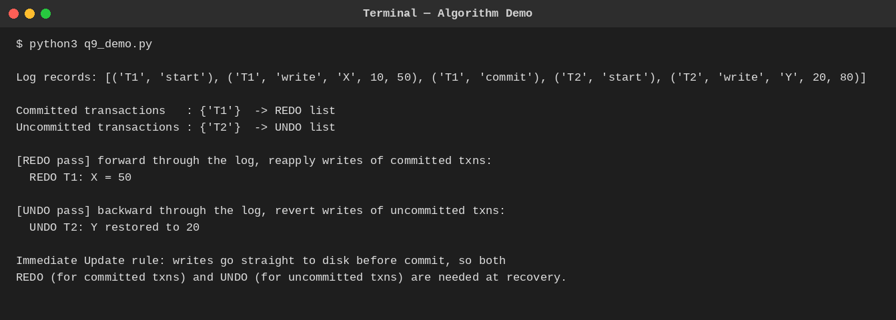
Fig. Q9 — REDO of a committed transaction and UNDO of an uncommitted one.
Q10. Write pseudocode for a database connectivity manager that handles connection pooling, query execution, and exception rollback.
BL4 – Analyze | Marks: 5
Pseudocode
ALGORITHM ConnectionPoolManager(poolSize):
pool <- QUEUE of poolSize pre-opened connections

FUNCTION ACQUIRE():
IF pool is empty THEN BLOCK caller until a connection is released
RETURN pool.dequeue()

FUNCTION RELEASE(conn):
pool.enqueue(conn)

FUNCTION RUN_QUERY(query):
conn <- ACQUIRE()
TRY:
conn.BEGIN_TRANSACTION()
result <- conn.EXECUTE(query)
conn.COMMIT()
RETURN result
CATCH exception:
conn.ROLLBACK() // undo partial effects of the failed transaction
LOG the exception
FINALLY:
RELEASE(conn) // connection always returned, even on failure
END ALGORITHM
Explanation
A connection pool avoids the cost of opening a fresh database connection per request by keeping a small set of live connections that callers borrow and return. RUN_QUERY wraps every query in a try/catch/finally: the transaction is begun, executed, and committed on success; on any exception it is rolled back instead so no partial write is left behind; and the finally block guarantees the connection always goes back to the pool, whether the query succeeded or failed — preventing connection leaks under error conditions.
Executed Demo
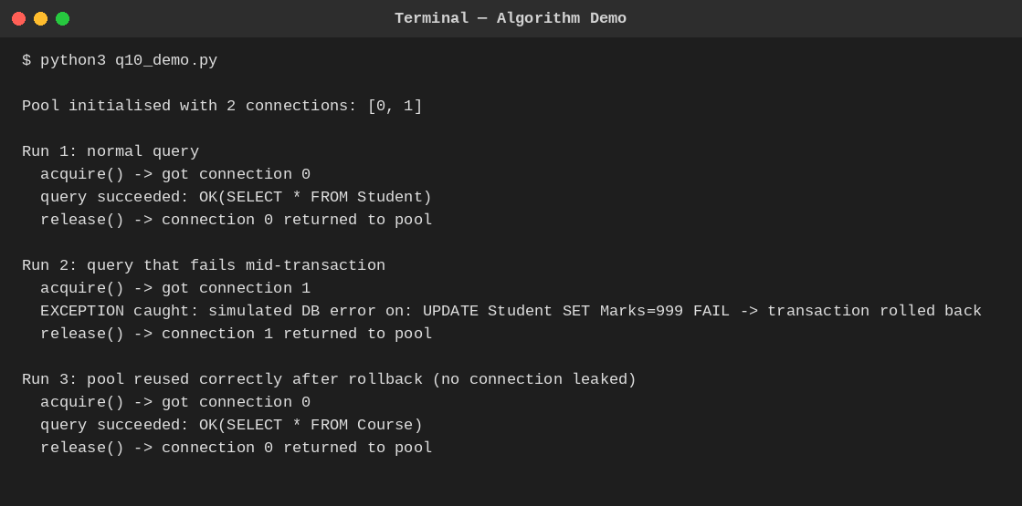
Fig. Q10 — Pool serving a normal query, a failing query with rollback, and reuse afterward.
End of Answer Key

